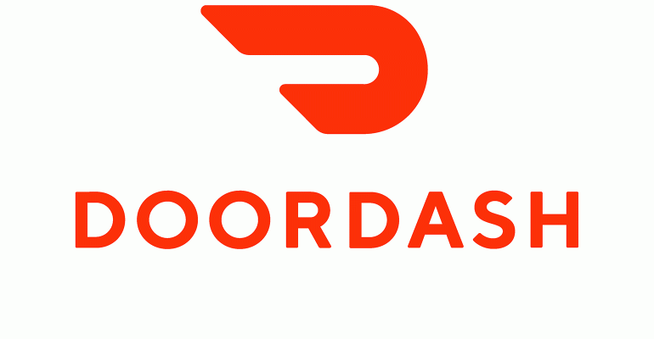

*Goodness, a very loyal DoorDash customer, hesitates to order her favorite snacks due to high delivery charges and subsequent tips. Frizzle, a very prominent merchant restaurant refuses to accept orders for light meals and snacks below $10 due to the commission charges they would have to pay for facilitate this order. To address this issue, DoorDash has introduced Autonomous dashers that we call Robo-Dasher to cater for Goodness and Frizzle issues. We, as a team, are excited to introduce the ‘Robo-Dasher Tracker” to help serve our customers in the San Francisco Area*

*The Customer Support and Operations team within DoorDash will be equipped with this powerful tool soon. They could help the customers to track their food real time, track the exact location of Robo-dasher, get the time to delivery location, exact geo-coordinates and map location of the Robo-dasher, etc.*

*This is not just to locate or track their status. They could also control those robots in the field to re-route them, to add a new delivery task, cancel and return orders to merchant restaurants. This app is designed for our Customer Support and Operations team so that they can help serve all our customers better.*

*We launched our Fleet Management App already for a small segment of operations team.*

*We have successfully executed multiple field tests with Robo-Dasher to deliver to customers and collected user feedback.*

***‘Perfect delivery and believe it or not, this seems like one of those future tech from the movie and yes the delivery fee is lower’***

*More functionality are being developed we are looking forward to launch it in all US markets soon!*

*I would like to thank the entire team who has worked in realizing this App. This launch would not be possible without their tireless and detailed work.*

*Thank!!!*

**AYILEYE DAYO,**

**Product Manager**

On behalf of all my team members who made this happen